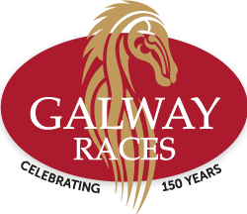
Dear All,
On behalf of the GSBA I would like to invite all members to attend our annual visit to the Galway Races on Monday the 25th July 2022.
This will be our return visit to the Monday race meeting after two years absence and we expect that it will be extremely popular. NB* The Ticket Office at the Galway Races have warned that tickets to our usual spot in the Millennium Stand reserved seating area will sell out well in advance of the day.
Having been a great day for everyone who has attended in recent years we are sure this year will be no different!
As regular attendees we have been offered the following package and in order to avail of same, you should contact the ticket office on 091 700 100 and state you are a member of the GSBA
The Premium Festival Package includes
- 1 x Adult Admission Ticket
- 1 x Reserved Seat Badge with Access to the Corrib Bar with Panoramic Views of the Finish Line (a‘Top Tip’ from the staff at Galway Races)
- 1 x Racecard
- €6 Drink Voucher
- €5 Betting Voucher
Price: €55 per person Monday
We hope to see you there.
John Martin - President - GSBA

