Centralising the legal aid panels for solicitors

As of November this year, court offices will no longer have to set up and maintain the legal aid panels for their county. A new process will allow solicitors will complete a form on which they will indicate which County's panels they wish to be placed on and which will then be sent to a new email address legalaidpanel@courts.ie.

These applications will be then be processed in the Centralised Office into individual panels for each county. This office will then provide regular updates to the County Registrar in each county and ultimately send the updated panels to the Department of Justice.

As you will appreciate, hopefully, this will be a win/win situation for everyone involved with work moving out of Court offices while making it easier for solicitors to register.

A copy of the new Form and Instructions is attached and the information is also available on the Courts Service website – details below.

Any queries in relation to the 2022 legal aid panels should be directed to this new email address while queries in relation to legal certificates and appearances will continue to be dealt with by the local Court office dealing with a particular case. Queries in relation to payments will continue to be a matter for the National Shared Services Office in Killarney.

2 matters of clarification

(1) Only Tax Clearance certificates expiring in 2022 should be submitted to legalaidpanel@courts.ie as this office will only be taking over the preparation for 2022.

(2) The form to be submitted must be in Excel. You should download the form in this format onto your network and complete same. The form, in Excel format, should be completed and then submitted. This will speed up the registration process.

Courts Service Website
Menus Added

Across the top of every page there is a dropdown menu
legal aid has been added under the Rules and Procedures dropdown

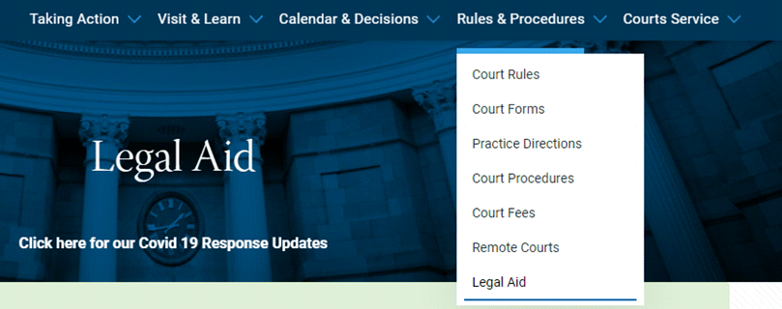

Additionally when you are on any rules and procedures page there is a list/menu on the left of all Rules and procedures sections
Legal Aid has been added to this as well

Clicking on the link in that dropdown or in the left menu will bring you to the page with the information and links:
https://www.courts.ie/legal-aid

