Private and confidential
President of Bar Association

15 November 2021

By Email:

Re: LSRA consultation on creation of new profession of conveyancer

Dear President,

As you may already be aware, as required under section 34 (1)(i) Legal Services Regulatory Act 2015, the Legal Services Regulatory Authority (LSRA) is currently inviting interested parties to make written submissions ahead of its report for the Minister for Justice in relation to the creation of a new profession of conveyancer in Ireland.

As part of the preparation process for the Law Society’s submission, via eZine bulletin on 13 October last, it invited interested solicitors with relevant experience and knowledge to provide their views to the following email address conveyancingsubmission@lawsociety.ie to ensure that these are reviewed as part of the process.

I am inviting you to provide, via the email address above, any further views or recommendations that your Association or members may have in relation to the consultation by Monday 22 November 2021.

Issues to be considered include the impact that the establishment of a new profession of conveyancer could have in terms of competition in the provision of legal services and the specific implications, positive or negative, for the legal services sector and the solicitors’ profession. For the full list of relevant questions that the LSRA has provided, see section 4 of the consultation document available here.

With every good wish,

Yours sincerely,

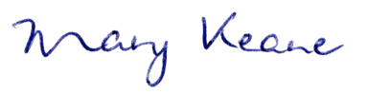
Mary Keane
Director General

